TC-CMS-011
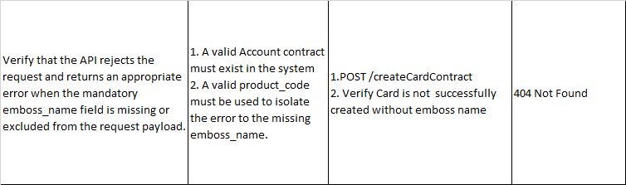
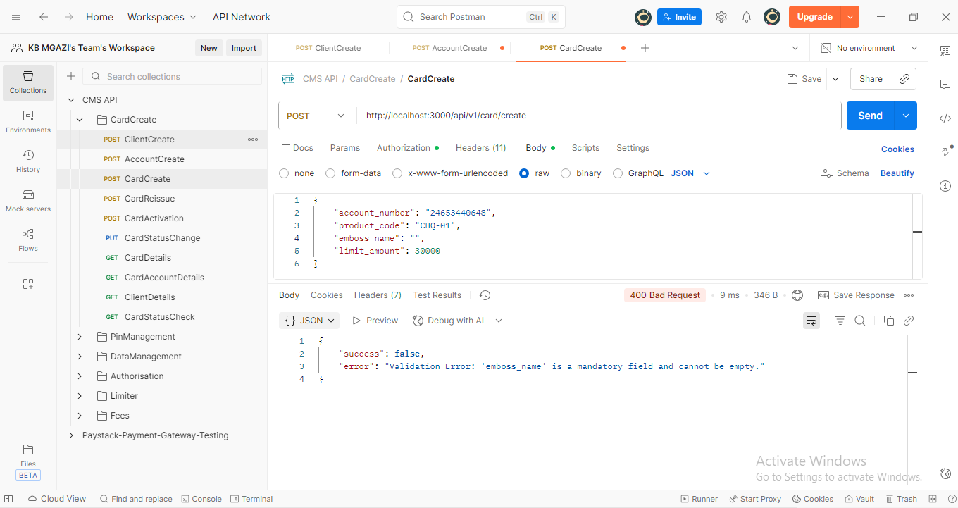
Request:
{
"account_number": "24653440648",
"product_code": "CHQ-01",
"emboss_name": "",
"limit_amount": 30000
}

Response:
{
"success": false,
"error": "Validation Error: 'emboss_name' is a mandatory field and cannot be empty."
}

